
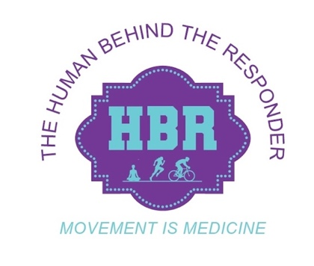
Suzanne Smith
Springfield, Alaska, USA

INTRODUCING Joe Smith, Husband, Father, Carpenter, Car Collector, 40-year Paramedic
- I am pleased to join HBR and to volunteer as one of the lead support crews for C2C-Two in June 2025
EARLY LIFE:
- Birth & birthplace
- Childhood & family background.
- Schooling.
School & Beyond:
- High school/College.
- Other education & activities.
How Did I Meet Members of HBR?
- Important Events.
- Inspirational moments/Persons.
- Life Changing Moments.
Career Highlights:
- Important Events.
- Things that drawn attention of others.
- Awards & Achievements.
Where are you now?
- Present life of them.
Why is giving back and supporting HBR is important to me?

